Heathfield
Primary
School

Spelling Policy 2016

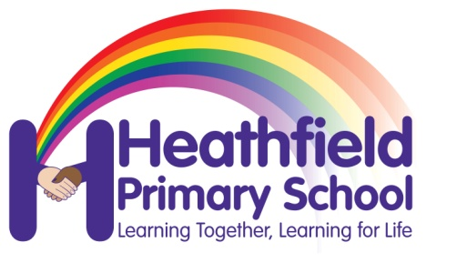

Signed Head
Signed Chair
Date

Spelling is an integral part of children’s reading and writing development. As children develop spelling competency, their confidence and independence in writing will increase.

The aims of spelling at Heathfield Primary School
- Children to become confident, independent spellers using a range of skills and strategies.
- Children to have an interest in words and their meanings (dictionary work including etymology)
- Children to have a growing vocabulary.
- Children to use spelling skills in many areas of the curriculum
- Ability to use prefixes and suffixes to alter word meanings (morphology)

Objectives
To teach children to:
- Spell confidently the words that they are using frequently in their writing
- Spell new words with an increasing range of phonetic knowledge.
- Learn to check and correct spellings using strategies as listed below
- Learn strategies to spell unknown words correctly.
- Building of quality teaching of phonics
- Ensure full coverage of National Curriculum requirements
- Top develop spelling strategies: morphology, etymology, patterns in words

Teaching and Learning Strategies.
Spelling is taught 5 times over 10 days, using the cycle listed below. Year 2-6 to use No Nonsense Spelling Scheme as a guide.
Revise
Activate prior knowledge Revisit previous linked learning

Teach
Introduce the new concept Explain
Investigate Model

Practise Individual/group work
Extend/explore the concept independently Investigate
Generalise

Apply/Assess
Assess through independent application Explain and demonstrate understanding

This enables pupils to choose the strategies they find most effective for learning different words. The strategies developed at Heathfield are listed below.
:

Look, say, cover, write, check | This is probably the most common strategy used to learn spellings.  Look: first look at the whole word carefully and if there is one part of the word that is difficult, look at that part in more detail.  Say: say the word as you look at it, using different ways of pronouncing it if that will make it more memorable.  Cover: cover the word.  Write: write the word from memory, saying the word as you do so.  Check: Have you got it right? If yes, try writing it again and again! If not, start again – look, say, cover, write, check.
Trace, copy and replicate  (and then check) | This is a similar learning process to ‘look, say, cover, write, check’ but is about developing automaticity and muscle memory.  Write the word out on a sheet of paper ensuring that it is spelt correctly and it is large enough to trace over. Trace over the word and say it at the same time. Move next to the word you have just written and write it out as you say it. Turn the page over and write the word as you say it, and then check that you have spelt it correctly.  If this is easy, do the same process for two different words at the same time. Once you have written all your words this way and feel confident, miss out the tracing and copying or the tracing alone and just write the words.
Simultaneous Oral Spelling | Children to complete the grid listed below.
  Model and write (rainbow write, trace, pyramid) | copy
  Spell from memory (covering row above) | Write with eyes closed
Segmentation strategy | The splitting of a word into its constituent phonemes in the correct order to support spelling.  Teachers may also use syllable grids. This may be more appropriate for older learners.
Drawing around the word to show the shape | Draw around the words making a clear distinction in size where there are ascenders and descenders. Look carefully at the shape of the word and the letters in each box. Now try to write the word making sure that you get the same shape.
Quick Write | Writing the words linked to the teaching focus with speed and fluency. The aim  is to write as many words as possible within a time constraint.  Pupils can write words provided by the teacher or generate their own examples. For example, in two minutes write as many words as possible with the /iː/ phoneme.  This can be turned into a variety of competitive games including working in teams and developing relay race approaches  Quick write grid: spell words; root word – suffix patterns (child, children, childish, childhood, childlike, childless)  KS1 – The Ladder Tracker
Spelling Investigation | Teacher to give children words and ask them to explore patterns (teacher to consider patterns).  See 9 essential strategies and approaches for more information.
.

In practise sessions teachers may wish to use: Spelling games and activities booklet. Rhere

Drawing an image around the word | This strategy is all about making a word memorable. It links to meaning in order to try to make the spelling noticeable.  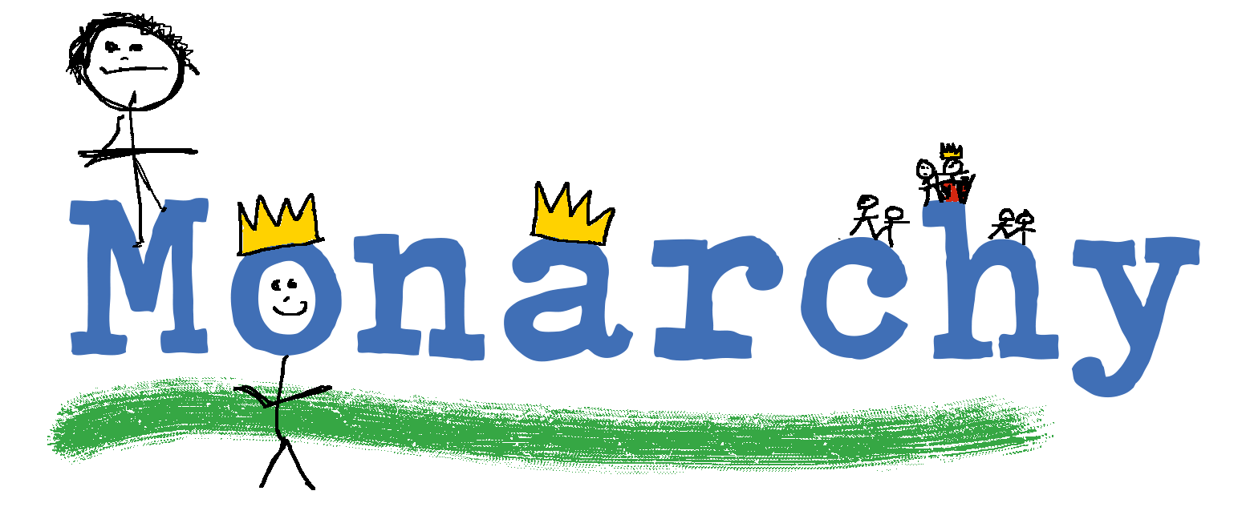  You can’t use this method as your main method of learning spellings, but it  might work on those that are just a little more difficult to remember.
Words without vowels | This strategy is useful where the vowel choices are the challenge in the words. Write the words without the vowels and pupils have to choose the correct grapheme to put in the space. For example, for the word field:
Pyramid words | This method of learning words forces you to think of each letter separately.  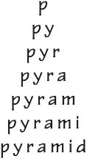  You can then reverse the process so that you end up with a diamond.
Other strategies | Other methods can include:  - Rainbow writing. Using coloured pencils in different ways can help to make parts of words memorable. You could highlight the tricky part s of the word or write the tricky part in a different colour. You could also write each letter in a different colour, or write the word in red, then overlay in orange, yellow and so on.  - Making up memorable ‘silly sentences’ containing the word  - Saying the word in a funny way – for example, pronouncing the ‘silent’ letters in a word  - Clapping and counting to identify the syllables in a word.

EYFS – children will be taught phonics daily. They will begin to learn the high frequency words. Children will be streamed from Nursery and Reception in Autumn Term according to the Phonics Phase they are working towards.

Year 1– Phonics is streamed based on phonics assessments which will be carried out half termly. Children are put into groups according to the phase they are working on. Within the phonics sessions children will be taught to revisit their last session, to be introduced to new sounds/rules and they will do an application activity based on the objective. In Year 1, most children should know all the high frequency words. This will be sent home for children to practice weekly. The expectation is that most pupils will complete phase 5 phonics before the end of Year 1.
In Year 2, children will move to No Nonsense spelling scheme. Spelling sessions must take place on five occasions on across two weeks. Lessons follow revise, teach, practise and apply approach.
Planning can be found in W:\Communication Team\Spelling.
The spelling pathway gives the medium term planning for each year group. The teacher book lists lessons and has a resource bank. Pupils will be expected to apply spelling rules and key words across the curriculum.

Pupils assessed at working below age-related expectation will receive targeted phonics teaching.

Key Stage 2
In Key Stage Two, children will continue with the No Nonsense spelling scheme. Spelling sessions must take place on five occasions on across two weeks. Lessons follow revise, teach, practise and apply approach.
Planning can be found in W:\Communication Team\Spelling.
The spelling pathway gives the medium term planning for each year group. The teacher book lists lessons and has a resource bank. Pupils will be expected to apply spelling rules and key words across the curriculum. Pupils will have a spelling log where they will record spelling starters and the practise tasks pupils carry out in guided reading sessions. Pupils spelling will be tested once per week.

Pupils who are working below age-related expectation will be assessed and work will be targeted to their specific needs.

Marking Spelling
It has long been accepted that to highlight every spelling in a child’s writing can be especially damaging for the very child we support most. A marking focus will be based upon individual/group need. Using the ‘zero tolerance’ approach the aim will be for words to be written accurately not just in isolation or in a test, but in ordinary classroom activities.
The focus for this will initially be: homographs, homophones, high and medium frequency words and the common exception words.

It is important when marling spellings to focus on the part of the word that the pupils have misspelt rather than the whole word. This will help to further develop spelling competency.

SEN
Where a specific need in spelling is identified, it is good practice for teachers use a group overview sheet. The aim is to identity patterns in children’s spelling mistakes in order to establish teaching priorities or create groups where children have similar spelling characteristics or needs. For further information see: A spelling intervention.

Assessment
EYFS - Assessment is ongoing and will take place weekly and half termly based on phonics.

Key Stage 1 – Assessment is ongoing and will take place weekly and half termly based on phonics. Year 2 will also be tested against the optional QCA spelling tests.

Key Stage 2– Assessment is ongoing and will take place weekly and half termly based on phonics. Children will also be tested against the optional QCA spelling tests.

Resources
Letters and Sounds
No Nonsense Spelling
Spelling logs (every child)
Dictionaries
Websites
Phonics play

Spelling Policy: Communication Team
September 2016
Updated November 2016

