boltonmusicservice.com
@BoltonMusicCent

Making Music at Home – EYFS – week 2
W  A  R  M  U  P | Hello everyone, this week we are going to find sounds using our bodies.  The music playing is Old Suzannah – can you work out what it is played on?  https://www.youtube.com/watch?v=xsAVNEAdyT4  Did you keep up? Maybe you could make different actions to fit the song.
S  I  N  G  I  N  G | 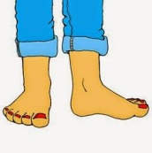  Let’s sing a song which uses lots of sounds we can make  https://www.youtube.com/watch?v=f-EVUKcSSVY  Was there a sound when you wriggled your head?  Maybe you could make a sound for that action with your mouth.
A  C  T  I  V  I  T  Y | 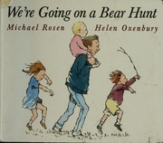  Have a listen to this story - how many sounds can you hear?  How does Michael Rosen make the sounds?  We’re Going on a Bear Hunt -  https://www.youtube.com/watch?v=0gyI6ykDwds  Can you make up your own sounds for the story – or make up your own bear hunt – where would it go? What sounds could you make for it?
Please send your video clips to your school and ask them to share on your schools twitter account. Don’t forget to ask them to include us @boltonmusiccent and the #keepmakingmusic in the tweet.
Have Fun making music!
Keep safe and see you soon!
Mrs Becker

