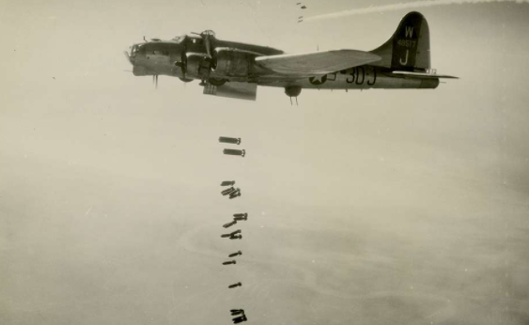

Year 6 homework

Did the world defeat hate? (WW2)

Spring 1

History

Write a fact file about Anne Frank.   
Gather as much information as you can.

Art

Create a piece of artwork based on the Blitz.

**Challenge**

Can you create a word search based on key World War 2 vocabulary?

Please complete the tasks below by Thursday 10th February. Tasks can be completed in any order. Tasks must be presented neatly and demonstrate good subject knowledge.

Weekly homework- Use your Reading Plus and Times Table Rockstar log ins to access these websites at home. Continue to read your book as much as possible.

English

Write a poem about the Blitz. Try and use different features of poetry throughout your poem.

Maths

Maths homework will be given out based on our maths learning in school when appropriate.

Times Tables Rockstars to maintain your fluency with multiplication and division.

Geography

Create a map of your own city.

Highlight the physical and human features within your city.