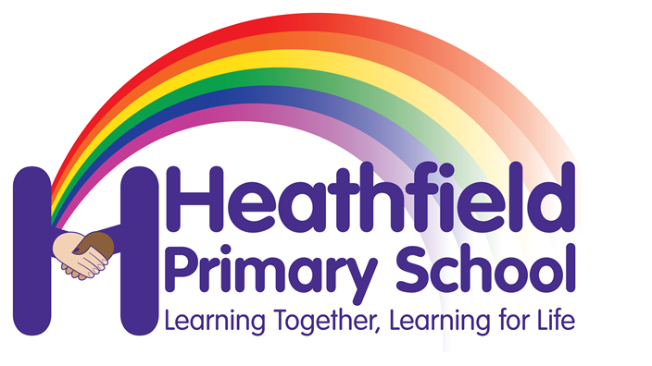

Heathfield Primary School

UNIFORM POLICY

Our Mission Statement:

Learning together, Learning for Life

Chair of Governors | Zulfi Jiva
Headteacher | Mr M D Thornley
Policy written by | Marl Thornley
Date approved by governors | October 2022
Date of next review | October 2023
Committee Responsible | Finance and Resources

CONTENTS
1.AIMS
2. HEATHFIELD’S LEGAL REQUIREMENTS
3. LIMITING THE COST OF SCHOOL UNIFORM
4. EXPECTATIONS FOR SCHOOL UNIFORM
5. EXPECTATIONS FOR OUR SCHOOL COMMUNITY
6. MONITORING ARRNAGEMENTS

AIMS
This policy aims to:
- Set out our approach to requiring a uniform that is of reasonable cost and offers the best value for money for parents and carers
- Explain how we will avoid discrimination in line with our legal duties under the Equality Act 2010
- Clarify our expectations for school uniform

2. HEATHFIELD’S LEGAL REQUIREMENTS

The Equality Act 2010 prohibits discrimination against an individual based on the protected characteristics, which include sex, race, religion or belief, and gender reassignment.
To avoid discrimination, our school will:
- Avoid listing uniform items based on sex, to give all pupils the opportunity to wear the uniform they feel most comfortable in or that most reflects their self-identified gender
- Make sure that our uniform costs the same for all pupils
- Allow all pupils to have long hair (though we reserve the right to ask for this to be tied back)
- Allow all pupils to style their hair in the way that is appropriate for school yet makes them feel most comfortable
- Allow pupils to request changes to swimwear for religious reasons
- Allow pupils to wear headscarves and other religious or cultural symbols
- Allow for adaptations to our policy on the grounds of equality by asking pupils or their parents to get in touch with Miss. Wilkinson or Mrs. Rebton via the school office or parents@heathfield.bolton.sch.uk, who can answer questions about the policy and respond to any requests

LIMITING THE COST OF SCHOOL UNIFORM
Our school has a duty to make sure that the uniform we require is affordable, in line with statutory guidance from the Department for Education on the cost of school uniform.
We understand that items with distinctive characteristics (such as branded items, or items that have to have a school logo or a unique fabric/colour/design) cannot be purchased from a wide range of retailers and that requiring many such items limits parents’ ability to ‘shop around’ for a low price.
We will make sure our uniform:
- Is available at a reasonable cost
  - Heathfield Humper £9, Cardigan is £10 and hoody is £12
  - Heathfield Polo shirt is £8 and PE t short is £5
  - Cheaper supermarket versions are available for polo shirt and PE t shirt
  - Pants, shorts, gingham dresses are generic items and can be purchased from supermarkets or equivalent
- Provides the best value for money for parents/carers
We will do this by:
- Carefully considering whether any items with distinctive characteristics are necessary
- Limiting items with distinctive characteristics to low-cost or long-lasting items, such as ties
- Considering cheaper alternatives to school-branded items, such as logos that can be ironed on, as long as this doesn’t compromise quality and durability
- Avoiding specific requirements for items pupils could wear on non-school days, such as coats, bags and shoes
- Keeping the number of optional branded items to a minimum, so that the school’s uniform can act as a social leveler
- Avoiding different uniform requirements for different year/class/house groups
- Avoiding different uniform requirements for extra-curricular activities
- Considering alternative methods for signaling differences in groups for interschool competitions, such as creating posters or labels
- Making sure that arrangements are in place for parents to acquire second-hand uniform items
- Avoiding frequent changes to uniform specifications and minimising the financial impact on parents of any changes
- Consulting with parents and pupils on any proposed significant changes to the uniform policy and carefully considering any complaints about the polic
EXPECTATIONS FOR SCHOOL UNIFORM
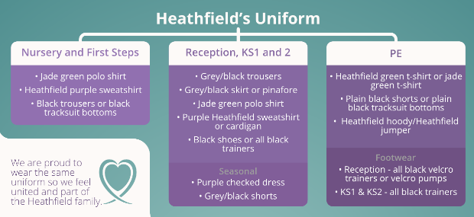

- Generic jade green t shits are acceptable.
- Children can bring a waterproof coat to school
- Studded earing only are allowed
- Jade Green t- shirt for uniform and PE does not need to be the Heathfield branded item.

Swimming kit expectations (based on Swimming pool expectations)
- Children must bring a towel, swimming kit etc. in a bag.
- No Bermuda shorts or cut offs
- Full Lycra swim suits (no bikinis)
- No jewellery including earrings
- No aerosol sprays (deodorant)
- Children with long hair must wear a swimming cap

WHERE UNIFORM CAN BE PURCHASED

School uniform can be purchased via the school website and/or from Whittakers and Smart clothing. Pants, shorts, gingham dress, jade green t shirts etc. can be bought more widely from high street retailers.

PATH (Parent and Teachers of Heathfield) run three ‘Nearly New Sales’ throughout the academic year

EXPECTATIONS FOR OUR SCHOOL COMMUNITY
Pupils are expected to wear the correct uniform at all times (other than specified non-school uniform days) while:
- On the school premises
- Travelling to and from school
- At out-of-school events or on trips that are organised by the school, or where they are representing the school
Pupils are also expected to contact Head teacher via parents@heathfield.bolton.sch.uk if they want to request an amendment to the uniform policy in relation to their protected characteristics.
PARENTS AND CARERS
Parents and carers are expected to make sure their child has the correct uniform and PE kit, and that every item is:
- Clean
- Clearly labelled with the child’s name
- In good condition
Parents are also expected to contact head teacher if they want to request an amendment to the uniform policy in relation to:
- Their child’s protected characteristics
- The cost of the uniform
Parents are expected to lodge any complaints or objections relating to the school uniform in a timely and reasonable manner.
Disputes about the cost of the school uniform will be:
- Resolved locally
- Dealt with in accordance with our school’s complaints policy
The school will work closely with parents to arrive at a mutually acceptable outcome.
STAFF
Staff will closely monitor pupils to make sure they are in correct uniform. They will give any pupils and families breaching the uniform policy the opportunity to comply, but will follow up with the head teacher if the situation doesn’t improve. Staff will give children Uniform slips, highlighting which part of the uniform policy is not being upheld.
Ongoing breaches of our uniform policy will be dealt with by the Headteacher, Assistant Headteacher and Learning Mentor.
In cases where it is suspected that financial hardship has resulted in a pupil not complying with this uniform policy, staff will take a mindful and considerate approach to resolving the situation.
GOVERNORS
The governing board will review this policy and make sure that it:
- Is appropriate for our school’s context
- Is implemented fairly across the school
- Takes into account the views of parents and pupils
- Offers a uniform that is appropriate, practical and safe for all pupils
The board will also make sure that the school’s uniform supplier arrangements give the highest priority to cost and value for money, for example by avoiding single supplier contracts and by re-tendering contracts at least every 5 years.

MONITORING
This policy will be reviewed annually by Head teacher. At every review, it will be approved by Quality of education committee.

