Heathfield Primary School
Mathematics Policy

Our Mission Statement:
Chair of Governors | Zulfi Jiva
Headteacher | Mark Thornley
Policy written by | William Ackerley (Maths Lead)
Date approved by governors | 2nd February 2022
Date of next review | April 2022
Committee Responsible | Learning Challenge
Learning together, Learning for Life

RATIONALE

At Heathfield, our curriculum lays out the way we teach our children to achieve our mission statement; Learning together, learning for life.

The curriculum consists of all the planned activities and routines that we organise in order to promote learning, confidence and self-esteem. It includes not only the formal requirements of the National Curriculum, but also the range of extra-curricular activities that the school organises in order to enrich the experience of the children. The children at Heathfield are provided with an inter connected curriculum that promotes meaningful connections between concepts and knowledge (Heathfield Head), develops genuine and robust character traits to prepare children for life in the modern world (Heathfield Heart) and opportunities for children to use and apply their Head and Heart to answer learning questions (Heathfield Hands) resulting in knowledgeable, physically and mentally healthy children that achieve their potential and have a solid foundation to become life-long learners.

INTRODUCTION
This policy outlines the teaching, organisation and management of mathematics taught and learned at Heathfield Community Primary School. The policy reflects the aims of the 2014 National Curriculum for Mathematics and Early Years outcomes (supported by Development Matters). The school uses the ‘White Rose Maths’ scheme of work to provide a sequenced and consistent curriculum overview which is followed by Years 1 to Year 6 and has created its own ‘I can statements’ which are linked to development matters in EYFS based on the updated EYFS Framework 2021
Declarative knowledge: static in nature and consists of facts, formulae, concepts, principles and rules e.g. 1+1 = 2 or the concept of addition.
I know that…

Procedural knowledge: recalled as a sequence of steps such as methods, algorithms, procedures e.g., the steps to complete a column addition sum
I know how…

Conditional knowledge: ability to reason or to solve problems by using a strategy for pupils to use to solve or complete.
I know when…

COVID-19 Lockdown/Remote learning
During periods of national lockdown or instances of bubble closures the curriculum is delivered through Tapestry/Microsof teams. These sessions, whilst different in the nature of delivery, have continued to follow the long-term overview of the mathematics curriculum.
Prioritisation of curriculum following Spring Term school closures
Whilst teaching of mathematics continued during this period of school closures, on return to school the mathematics curriculum was ‘prioritised’ for the remainder of the year. Those year groups following the National Curriculum were instructed to follow the prioritisation document (see appendix) for the remainder of the 2020-21 school year.
CURRICULCUM INTENT
Mathematics is a creative and highly interconnected discipline that has been developed over centuries, providing the solution to some of the world’s most intriguing problems. It is essential for everyday life; critical to science, technology and engineering; necessary for financial literacy and all crucial for all forms of employment.
High quality mathematics experiences, therefore, provide:
- a foundation for understanding the world;
- the opportunity to reason mathematically;
- an appreciation of the power of mathematics;
- a sense of enjoyment and curiosity.
AIMS
To ensure all pupils:
- develop the conceptual understanding of all pupils; Concrete pictorial abstract (CPA)
- Develop strong ‘number sense’ and understanding of early number skills on which they can build a firm foundation of mathematical knowledge and understanding
- ensure our pupils become fluent in the fundamentals of mathematics;
- support the ability to recall and apply knowledge rapidly and fluently;
- develop the mathematical confidence of all children;
- reason mathematically following a line of enquiry;
- apply mathematical reasoning to every relevant subject
- ensure pupils can calculate efficiently.
- enjoy mathematics
Mathematics is an interconnected subject in which requires pupils to move fluently between representations of mathematical ideas. The programmes of study are, by necessity, organised into distinct domains, but pupils should be given the opportunity to make rich connections across mathematical ideas to develop fluency, mathematical reasoning and competence in solving increasing sophisticated problems. They should apply their mathematical knowledge across all relevant subjects.
IMPLEMENTATION
From very early on in children’s school life, we expect children to use and understand numbers, which are abstract concepts. The CPA (concrete, pictorial, abstract) approach helps children achieve secure number sense – that is, a sense of what numbers really represent and how to use them mathematically. This is done through a series of carefully chosen representations – first using physical objects (concrete), then diagrams or pictures (pictorial), and ultimately using representations such as numerals (abstract) that help build pupils’ understanding of distinct mathematical structures and make connections between them. Research shows that greater success in having a good understanding of number at an early age has a positive correlation with success later on in education.
The expectation is that the majority of pupils will move through the programmes of study (Outlined in the White Rose Maths curriculum overview) at broadly the same pace. However, decisions about progress should always be based on the security of pupils’ understanding and their readiness to progress to the next step. Pupils who grasp concepts readily should be challenged through the use of rich and sophisticated problems (Reasoning, Problem solving & DIVES). Those not sufficiently fluent with earlier material should consolidate their understanding, including additional practise, before moving on.
MATHEMATICS and connections to other subjects within the National Curriculum
Whilst mathematics is taught discreetly, it is important to promote the use of mathematical understanding within other relevant areas of the curriculum.
Subjects where connections are made are:
Computing: including the application of coding skills and use of mathematical concepts such as number and shape, pupils at Heathfield enjoy opportunities to access mathematical question sets through the use of ‘Learning by Questions’ software accessed through Chromebooks and tablets across school.
Science: in areas which require an understanding of statistics, good understanding of mathematical concepts such as number and reasoning with statistics are important for pupils to be able to access and create data sets collected from scientific investigations and experiments.
SPOKEN LANGUAGE
The National Curriculum for mathematics reflects the importance of spoken language in for pupils’ across the curriculum – cognitively, socially and linguistically. The quality and variety of language that pupils hear and speak are key factors in developing their mathematical vocabulary and presenting a mathematical justification, argument or proof. They must be assisted in making their thinking clear to themselves as well as others and teachers should ensure that pupils build secure foundations by discussion to probe for misconception and challenge and extend where appropriate.
EARLY YEARS
Work undertaken within the foundation stage is guided by the recommendations set out in Development Matters and assessed at regular intervals using the Early Years Outcomes Document. Children are given opportunities to develop their understanding of mathematics through a range of activities that allow children to use, enjoy, explore practise and talk confidently about mathematics. Mathematics activities should be taught in all areas of the classroom. Consolidation and enrichment of mathematical concepts are provided through the use of challenges and enhancements.
PLANNING, LEARNING AND TEACHING
- Daily Mathematics lessons in KS1 & KS2 are 60 minutes

Starters include:
- Counting and/or times tables fact recall
- An element of ‘retrieval practice’ to allow children to recall knowledge, skills or facts that have already been learnt, thus helping to embed the learning further. The retrieval practice is deliberately and strategically planned to cover the four previous topics that the pupils have covered. And/or
- Pre-teaching – deliberately chosen tasks used within each block to ‘pre-teach’ facts which will help pupils to build an awareness of areas of mathematics which will be up-coming in their learning sequence. (Freeing up working memory)
Main lesson:
- New learning is outlined in WRM documentation and each unit is broken down into a series of ‘small steps’ which give opportunities for connections between mathematical structures and help pupils to ‘know and remember more’
- Pre learning fluency checks are used to understand all children’s starting point; from this teachers plan based on children’s prior knowledge. Children that have a higher pre learning fluency check score move onto reasoning and problem solving earlier in the teaching sequence. Children that have a lower score are provided with more varied fluency, scaffolding and practice (Further details below).
- Post tasks are used to celebrate progress made
- Questioning is used by all supporting adults to probe, support and extend learning.
- Where possible, mathematics should link to the real world, enabling children to develop an understanding of mathematics in the wider world.
- When solving problems, children will use the strategies from the problem-solving prompt questions.
- Children should be given the opportunity to reason mathematically every day. This will include daily opportunities for application. This may be in pupil work books, as plenaries or shared examples.
- Once pupils show proficiency (fluency) with the maths they are learning further opportunities to extend learning are offered through set ‘Reasoning’ and ‘Problem Solving’ activities and questions. For those who have shown a deep understanding of the new content ‘Dive’ questions or tasks are given which give opportunities for pupils to explore the mathematical concepts further.
- End of Unit ‘Tests’ will be used as retrieval practice. The tests are given at the end on the next unit. This provides enough time to interrupt the forgetting and informs teachers whether learning is in long term memory. Gaps identified on end of unit tests are used to inform starters.
- KS2 currently complete three 30-minute sessions of guided maths per week – this takes the form of Maths Masters which explicitly teaches pupils strategies for recalling and applying number facts. These sessions follow the ‘three Rs’ of Retrieval – Reasoning – Rule.
- KS1 have 5 x 15 minutes sessions per week in addition to their maths sessions. These ‘Maths Masters’ sessions focus on learning number facts up to 20 by the end of KS1 the expectation is that pupils can recall all facts and be able to explain how/why they are correct.
MATHS MASTERS
The intent of Heathfield Maths Masters is to improve children’s ability to develop number strategies to develop conceptual understanding and reach a high degree of procedural fluency, freeing up working memory to apply knowledge to more complex problem solving and reasoning.
Heathfield Maths Masters is a research based, systematic and structured approach on a defined set of addition, subtraction and multiplication facts and set of calculation strategies that builds on our innate ability to process quantities and improve children’s ‘number sense’ visually with concrete manipulatives and pictorial representations. Improving children’s number sense will improve the efficiency, accuracy and flexibility of number facts.
Each Maths Masters session follows a similar routine:
- Recall – We know from research into memory suggests that repeated retrieval of facts helps them to be imbedded into the long term memory.
- Reasoning – each session should have an element of ‘talk’ about number, either through reasoning as a group or in smaller groups. Examples can be discussing related facts and why they work or sharing ideas from a representation or model.
- Rules – opportunities to employ the mathematics that has been discussed. This can be done through whole class, or once more confident smaller group games applying the mathematics that is being taught. Here pupils will learn the rules of the games and also how mathematics has a consistent set of rules. E.g. 5+7 will always be 12 even if it is 15+7

EYFS
During Maths Masters sessions, sessions focus on development of pupils number sense. Initially focusing on the numbers 0-5 and then 0-10. Through the use of representations and manipulatives like the Rekenrek and tens frames pupils are taught to build mental pictures of numbers and focus on details such as the ‘fiveness’ of the number five. Teachers use resources from the NCETM ‘Mastering Number’ programme to ensure sessions are sequence to help further pupils understanding.

KS1
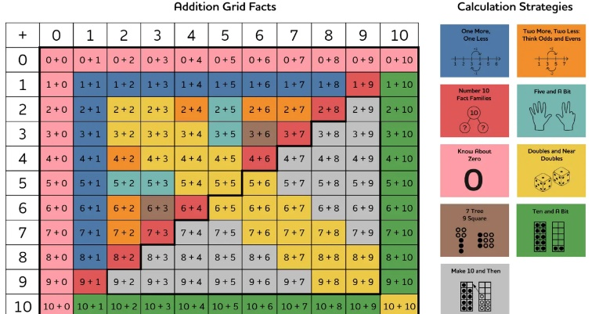
Through Maths masters’ sessions pupils in KS1 continue to build on their understanding of numbers up to 20. As in EYFS pupils practise their subitising and essential number skills to improve the automaticity of the recall of facts. By the end of KS1 the expectation is that pupils are fluent in recalling simple number facts ensuring that they begin KS2 with a confident understanding of number and the calculation strategies taught. Pupils complete half termly assessments to ensure that pupils are applying these strategies with confidence.

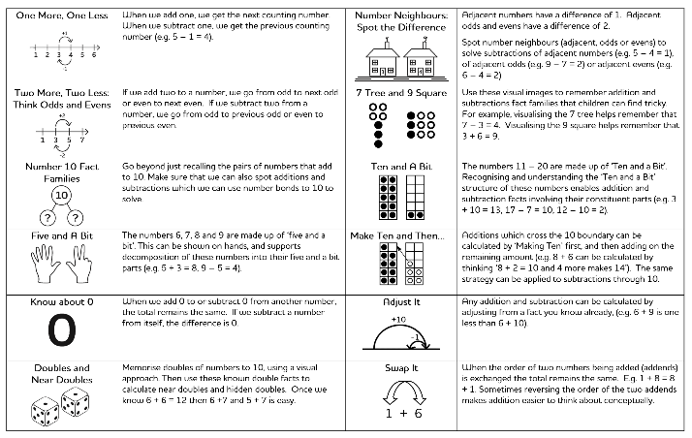

Year 3
Pupils in Year 3 are continuing to embed these calculation strategies. The Year 3 model will be reviewed and evaluated at the end of the academic year. This forms part of our recovery curriculum.
Year 4
Year 4 focuses on children’s fluent knowledge of multiplication recall and builds on the conceptual understanding of the links between multiplication, division and fractions. The Heathfield Times table Tracker is used to diagnose gaps in children’s knowledge (Diagnose), then through varied strategies alongside mathematical talk, reasoning and explanation children develop instant recall of facts rooted in conceptual understanding by:
- Using varied representations
- Practising little and often, through games
- Keeping the stakes low to keep emotional stress and anxiety to a minimum.
- Breaking down the times tables facts into manageable chunks.
- Only moving onto the next times tables when children have reached expected Level
- Mathematical talk and reasoning (Teach)
- Children are assessed using the PiXL tests to evaluate whether children have reached expected levels, showing they are secure in their knowledge and understanding. Times table tracker is updated.
- As a result of increased confidence children can apply their knowledge of timetables in other areas of the curriculum. (Apply)
- A 25-question multiplication test to be completed once every three weeks. 3-minute timer.
- Use of the times table tracker will inform class teacher and guide how two extra members of staff are assigned.
Year 5 & 6
Year 5 and 6 focuses on children applying their number sense to arithmetic.
- A 10-question arithmetic test is used to identify gaps in children’s learning (Diagnose) then through varied strategies alongside mathematical talk, reasoning and explanation children develop strategies rooted in conceptual understanding by:
- Using varied representations
- Direct instruction
- Regular practise/ over learning until children reach the expected level
- Keeping the stakes low to keep emotional stress and anxiety to a minimum.
- Mathematical talk and reasoning (Teach)
- Two-week cycle: Test, Teach x 4, Test
- Children are assessed using the diagnostic test to evaluate whether children are secure in their knowledge and understanding. (Test)
- The Maths Masters Arithmetic tracker is updated.
- As a result of increased confidence children can apply their knowledge in other areas of the curriculum. (Apply)
- For children that achieve 10 out of 10 on the diagnostic assessment, the teacher plans reasoning and problem solving dive activities on number, fraction, decimal, percentages and calculation. This should be recorded in Maths books. If there are no children that have scored full marks, the additional staff should focus on the highest 4 scores and address the gaps.
This is planned by the teacher.
In the Spring term of Year 6 pupils use Maths Masters sessions to review and share their skills and strategies to answer a wide range of test style questions.
(When working with Teaching Assistants) Deep Dive activities should be recorded in books with the title Maths Masters: Deep Dive.
Adults working with this group will follow the maths marking and feedback policy

PROGRESSION OF CALCULATION STRATEGIES
Refer to the White Rose Maths Progression documents and the Heathfield Calculation policy.
DIFFERENTIATION AND SUPPORT:
In order to ensure that all learners make progress, support and differentiated must be considered in each session. Strategies include:
- Challenging, age related, reasoning and problem-solving tasks underpinned by systematics, accurate assessment of pupils’ prior skills, knowledge and understanding;
- Timely support and intervention based on effective AfL;
- Ensuring feedback celebrates success and highlights how pupils can improve. Fix its are planned to enable children to respond to feedback.
- Practical resources (concrete and pictorial) enable children to develop mathematical concepts;
FEEDBACK
School feedback policy is applied in maths sessions. The most effective feedback is verbal and done at the point of learning. Feedback aims to give pupils time to reflect on their learning and celebrate the success that their hard work has achieved. Feedback will be given during sessions as well as with correct mathematical working celebrated with a green ‘tick’. Pupils will be given time either during lessons or at the end of a set unit of work to complete a reflection box question to share what they have learnt. These reflections are used to help embed the metacognition skills of pupils.
ASSESSMENT
Formative assessment occurs at all parts of the session and be used by all adults to consolidate and extend children’s learning. This is mainly achieved through the effective use of questioning, mini-plenaries, self-marking/peer-marking, verbal feedback and observation.
Green ticks/dots are used by teachers to denote correct working/mistakes or misconceptions which should be revisited ideally within the lesson time as to be used in conjunction with verbal feedback.
Small steps are highlighted in yellow to show that they have been achieved.
PRE AND POST ASSESSMENTS
Each block of mathematics is broken down into units of up to 3 weeks.
Each unit is preceded by a pre assessment with a range of fluency questions.
In instances where pupils complete a pre-unit check with full marks, the post-unit check will be replaced by an extended maths task decided by the class teacher that will provide challenge for the pupil’s reasoning or problem-solving skills – this will be referred to as a ‘DIVE’ task (Deeper learning challenge)
Pre-assessments and post assessments will take place between units. The pre-assessment will inform class teachers of objectives that children will need additional support with. The post-assessment will demonstrate the progress that children have made after the units. This allows children to see the progress they have made along with setting their own targets.
Summative assessment is carried out in line with the assessment calendar using year group specific PUMA assessments.
The final Summer term PUMA results will be used to produce a Question Level Analysis that will inform then next year group of any specific gaps which are prevalent within the year group as a result of interruptions to learning during the past two years.
DEVELOPMENT AND REVIEW
The monitoring of the standards of children’s work and the quality of learning and teaching is the shared responsibility of the Senior Leadership Team and the maths subject lead also involves supporting colleagues in the teaching of mathematics, being informed about the current developments in the subject and providing a strategic lead and direction for the subject. A named governing body is briefed to overview the teaching of mathematics in the school.
The maths lead will carry out formal development throughout the year to ensure monitor books using ‘on the pulse’ monitoring and will provide verbal feedback where appropriate to class teachers. Each book focus changes based on other monitoring outcomes

